**The Deputy Inspector General: What is it that you do here?**

Inspection Instructor, SAIG-TR, 703-805-3895 DSN: 655

[usarmy.belvoir.usaignet.mbx.tigs-instructors@mail.mil](mailto:Graham.m.stone.mil@mail.mil)

*“So what you do is you take the specifications from the customers and you bring them down to the software engineers?”*

*“That, that's right.”*

*“Well, then I gotta ask: why can't the customers just take the specifications directly to the software people, huh?”*

*“Well, uh, uh, uh, because, uh, engineers are not good at dealing with customers.”*

*“You physically take the specs from the customer?”*

*“Well, no, my, my secretary does that, or, or the fax.”*

*“Then you must physically bring them to the software people?”*

*“Well...no. Yeah, I mean, sometimes.”*

*“Well, what would you say… you do here?”*

*“Well, look, I already told you. I deal with the customers so the engineers don't have to!! I have people skills!! I am good at dealing with people!!! Can't you understand that?!? WHAT IS WRONG WITH YOU PEOPLE?!!!!!!!”*

This scene from the movie *Office Space* is analogous to the conversation that often takes place between a Deputy Inspector General and his or her Command Inspector General (CIG). Army Regulation (AR) 20-1 and the various guides and handbooks produced at The Inspector General School (TIGS) offer little regarding the specific responsibilities of the Deputy. The oft-overlooked *IG Reference Guide* contains a sample IG office standard operating procedure (SOP) that lists eight responsibilities shared by both the CIG and the Deputy, but no single responsibility is unique to either position. Therein lies the problem when attempting to answer the question, “What is it that you do here”? My experience serving as the Deputy for 13 months and the CIG for nine months in the 1st Cavalry Division (1CD) enlightened me from both perspectives on how to maximize the value of the Deputy IG. My hope is that I can impart to you insights that I gained while serving as a Deputy IG at the division level. Ultimately, the nature of the duties and responsibilities of the Deputy enable the CIG to establish his or her role in a way that best suits the individual IG office, and the perspectives that I offer are merely a series of options and possibilities best applied according to the IG maxim of “it depends.”

**1. Internal Office Management:** The Deputy IG is comparable to a chief of staff in most organizations. Ultimately, the Deputy IG runs the IG office in tandem with the IG NCOIC. The office’s SOP is critical for laying the foundation of a smoothly running office. The Deputy must own that document and enforce its use. The SOP cannot be a document that sits on a bookshelf gathering dust. Instead, it must be a how-to guide that complements existing IG doctrine (such as The Assistance and Investigations Guide, The Inspections Guide, AR 20-1, AR 1-201, etc.). The SOP that I wrote for 1CD contained details on the routine tasks internal to the office, such as key control, file management and storage, property accountability, correspondence routing, rating schemes, sponsorship responsibilities for new arrivals, load plans, setup of a field or deployed IG office, information specific to each IG function, and additional duties. Avoid repeating what is already published and focus in detail on how the particular IG office functions. What I considered most valuable were guidelines specific to Assistance and Investigations casework within the office. The SOP should address these areas specific to the unit:

1. Walk-in Procedures.
2. Non-walk-in Procedures.
3. Preliminary Analysis (how to document it case notes).
4. Opening the case in IGARS (case-label formats, what goes in problem areas, etc.).
5. Guidance on Information IGARs (overly abused; IG leaders lack visibility on case).
6. “Battle Drills” with formats for non-support cases, referrals of allegations to the command, and Whistleblower intake.
7. Guidance on correspondence with the various commands (who talks to whom; are Assistant IGs corresponding directly with brigade commanders, or is that correspondence left to the Deputy or CIG?).
8. Guidance on case notes (entry requirements for certain case milestones, such as intake, documenting preliminary analysis, referral actions, notifications, final responses, etc.).
9. Case-closure procedures, to include peer and supervisory reviews (What checklist are they using? What does it cover?), the filing of hard-copies, and guidance on any closing case notes (e.g., the IG NCOIC documenting a supervisory review).

2. The Deputy IG as Operations Officer: Deputy IGs must keep their fingers on the pulse of what operations are occurring within the unit and keep the members of the IG office situationally aware. Further, Operations Orders (OPORDs) are often required for inspections and specific teaching-and-training events or to operationalize detailed inspection plans from other IG organizations. The Deputy is typically the individual who writes the OPORDs for the IG office and maintains the internal Outlook calendar that tracks all meetings, appointments, and relevant unit events (ranges, APFTs, and other AR 350-1 events that require IG attendance). The Deputy also ensures that unit calendars, such as the long-range training calendar, accurately reflect IG inspections.

Moreover, the Deputy IG should organize and host a weekly update to the CIG. The weekly update can quickly overwhelm the CIG with information, so the Deputy must control what each IG briefs and how that IG briefs it, as well as ensuring the CIG provides clear guidance that everyone understands. The following agenda worked well for my office:

1. Case update (all brief)

- Each IG briefs the current status and next action

- IGs brief by exception any specific help needed from the CIG / Deputy / NCOIC

- Trends and analysis of cases discussed

2. Inspections Tracker (Inspections Chief or Deputy briefs)

- Status of external IG inspections

- Status of internal IG inspections

3. Upcoming week (Deputy briefs)

- Upcoming events in the Division with IG interest

- Attendees for battle-rhythm events

4. Budget update (Budget person or Deputy briefs)

- Status of funds

- Upcoming purchase requirements

5. Administrative notes (Deputy / NCOIC brief)

- Evaluation status

- Awards

- Leave / TDY / appointments

- AR 350-1 requirements

Divide the weekly update into multiple meetings (such as an A&I update, an Inspections update, and an administrative update) depending on the size of the IG office. The key thing is to ensure maximum participation from all assigned IGs and avoid having only the branch chiefs update the CIG.

**3. Inspections:** The role of the Deputy IG in the conduct of the Inspections function differs greatly in each IG office and depends on whether or not the IG office is authorized an Inspections Chief. Therefore, each IG section should seek the appropriate balance and division of responsibilities as appropriate. Regardless of circumstance, the Deputy maintains an oversight role at a minimum if he or she is not personally leading Inspections.

Command training guidance is a tool for disseminating Inspections information to the organization. The Deputy IG should develop and submit the IG’s portion of the training guidance. The submission should include a list of inspections approved by the Directing Authority for the upcoming fiscal year (to include which quarter they will be executed), an updated Organizational Inspection Program document (ask the OIP coordinator for this document, or develop it if you are the OIP coordinator), and an Inspections strategy that demonstrates how the IG Inspection Program supports the Commanding General’s guidance. Below is an example of an inspection approach:

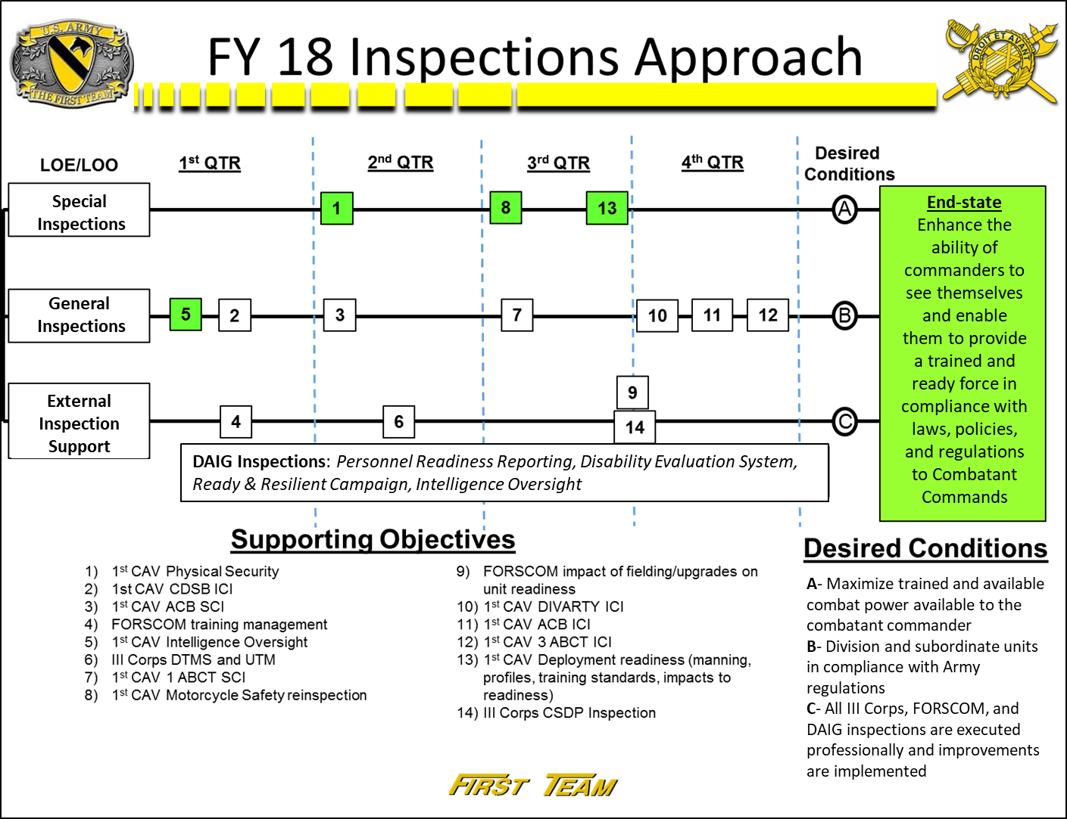

This inspection approach demonstrates the linkage between Inspections and the Commanding General’s approach to readiness (primarily availability of personnel and equipment for deployment) by building lines of effort that achieve the desired conditions necessary for the end-state to occur. As the Deputy, I took on some, but not all, of the duties of the OIP coordinator to provide stability to the program due to the high turnover rate of majors who were traditionally appointed as the Division OIP coordinator. Primarily, I developed the written OIP for the division and served as the executive agent for command inspections on behalf of the CG. This role meant I coordinated and tracked command inspections, relayed guidance, and compiled observations from staff inspectors in accordance with AR 20-1 and AR 1-201. I did not lead or participate in command inspections. My office played a small role in coordinating command inspections, which is why they appear in the inspections approach.

Other key Inspections-related responsibilities for the Deputy included serving as a division liaison for external IG inspections (such as from Department of the Army Inspector General), executing intelligence oversight inspections, providing inspections training to unit staff (to include subordinate unit staff), maintaining inspection records, proposing inspection topics, coordinating support requirements for inspection teams, and developing the fiscal year (FY) trends report. The FY inspections trends report should consolidate all inspections trends identified throughout all categories of inspections (command, staff, and IG) and be non-attributional to facilitate release to the Directing Authority.

**4. Assistance:** The Deputy IG personally works and supervises cases in the Assistance function. Most importantly, the Deputy IG is a great asset for a CIG to utilize for those Assistance cases that require delicate care. Whenever there is a “let me talk to your supervisor” moment between a complainant and an Assistant IG, the Deputy can provide input or work the case to eliminate friction and ensure faith in the IG system. The Deputy can also work high-profile cases when requested by a complainant (e.g., a Brigade Commander prefers that an Assistant IG not work a personal issue). From a supervisory standpoint, the Deputy is a quality controller who works in tandem with the IG NCOIC to ensure cases are worked in accordance with AR 20-1, The Assistance and Investigations Guide, and relevant regulations pertinent to the case.

Tracking the status of Assistance cases is critical to providing focus and the appropriate guidance to propel a case towards completion. Some offices can use IGARS to track the status of cases depending on the number of open cases and the labeling system established by the SOP. IG sections with numerous cases and an ineffective labeling system should consider developing an Excel spreadsheet that suits their needs, since clicking open 50 to 70+ individual cases in IGARS for a current status can become burdensome. Be sure to mark and secure as an IG record all products developed to track cases. As with the Inspections function, the depth of the Deputy’s role in supervising IGs depends on whether or not the IG section has an assigned A&I chief.

**5. Investigations:** The Deputy is a key player in Whistleblower Reprisal Investigations in the absence of a dedicated Investigations Chief. He or she tracks the status of Whistleblower Reprisal Investigations and carefully manages the timeline for their completion. The Deputy is also ideal for serving as an investigating officer in Whistleblower Reprisal Investigations for high-profile cases. This technique is highly dependent on the makeup of the Investigations section. In 1CD, the Deputy was the only non-Assistant IG other than the CIG. Utilizing the Deputy as an investigator was a necessity in that situation.

Although not IG Investigations, command referrals of allegations are quite common in most IG offices, and the Deputy should communicate with subordinate commands and the SJA to ensure receipt of the allegations by the command and to monitor or confirm their actions. Command IGs tend to be more personally involved in the Investigations function, since it is typically a higher point of interest for Directing Authorities. The Deputy helps manage information flow to the CIG and should transform raw information into executive-level points for the CIG. The CIG should receive structured information in a formal way (weekly update, internal priority information requirements, etc.) and in a standard format. The Deputy should develop, and the CIG should approve, those formats and information requirements so that the CIG can mentally manage the abundance of information regarding details of each Investigation without bias. Preventing Assistant IGs and IGs from overwhelming the CIG with information in random moments (walking into the CIG’s office, water-cooler talks, gossip about cases, etc.) is a process the Deputy must discipline, especially if there is a high case volume. Information discipline allows the CIG to get out of the office and be a consummate networker instead of sitting around and talking about cases all day. As with the Inspections and Assistance functions, the depth of the Deputy’s role in Investigations depends strongly on whether or not the IG section has an assigned Investigations Chief.

**Teaching and Training:** The CIG takes the most visible role in direct teaching-and-training opportunities. Engagements such as the Company Commander / First Sergeant Course, guest speaking at Leader Professional Development events, new Soldier welcome briefs, and office calls with new Commanders of subordinate units typically generate the expectation that the CIG, and not his or her Deputy, execute those engagements. The Deputy’s role in those engagements is a supporting role. Developing and coordinating presentation products, training aids, and talking points falls directly in the lap of the Deputy.

The Deputy is the primary author for IG newsletters that seek to inform the unit of current trends and how unit Commanders can remedy, or prevent, those trends from occurring in their organizations. An IG newsletter can serve as a platform to educate subordinate organizations on Army regulations and command policies. Since the Deputy is the information hub in an IG office, he or she tends to have the best understanding of Inspections, Assistance, and Investigation trends across the IG office and how best to prevent honest mistakes from hindering a command’s readiness status.

Below is an example of a newsletter that I developed in response to an uptick in medical-profile violations:

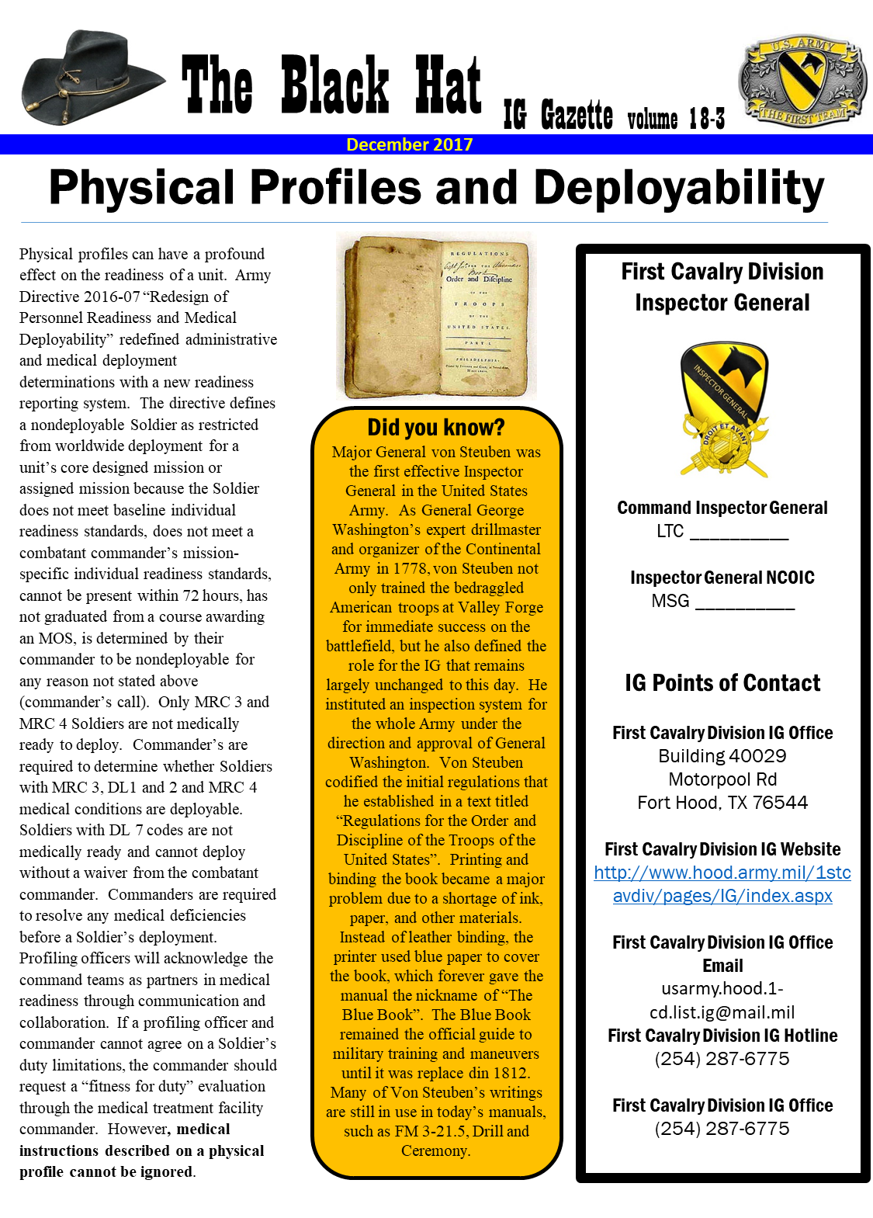

The Deputy can also conduct teaching and training as an embedded function within the other three functions. The Deputy’s impact in this capacity can be enormous on an individual level. Interactions that range from a phone call to a Company Commander explaining a regulation, or a follow-up explanation to a Soldier on why his or her complaint isn’t a violation of regulation, can change the tone of a Commander and complainant in a positive way by turning the conversation into an opportunity to educate the other party on the standard. The impact is particularly effective in diffusing a situation in which a Commander or complainant disagree with an Assistant IG who is attempting to teach and train him or her.

**7. Acting Command Inspector General:** The Deputy must be prepared to serve as the CIG at any time. The CIG is subject to illness, leave, PCS orders, or removal (permanent or temporary). I always tried to attend any meeting my CIG attended so that I remained updated on events in the command. The Deputy can’t go all the time, but he or she should go frequently enough to keep a finger on the pulse of the agenda and the CIG’s talking requirements in those meetings. The Deputy is typically more knowledgeable of day-to-day details of Inspections, Assistance cases, and Investigations than the CIG due to the Deputy’s role in overseeing those functions. This knowledge allows the Deputy to seamlessly assume the role of the CIG as it pertains to case knowledge.

The “people side” of the CIG’s job is where the Deputy can experience the most friction and that is where the Deputy must generate the opportunities to get out of the office and familiarize himself or herself with the people in the organization, particularly the Directing Authority. A good CIG should have the Deputy come along any time he or she engages the Directing Authority. Accompanying the CIG on these engagements creates a familiarity between the Directing Authority and the Deputy so that in the event the CIG is not available, the Deputy can pinch hit without missing a beat.

As a final disclaimer, every IG office is different. The methods that I have offered are things that were successful in my experience. One size does not fit all, so adjustments are necessary based on a specific IG section’s mission and makeup and the strengths and weaknesses of its members. One concept should ring true for all Deputies the next time he or she is asked, *“Well, what would you say… you do here”?* The Deputy should respond with *“A little bit of everything!”*